d)

if the inductor current gets to 0, the device will go into DCM.

When the switch is off,

$$L*\frac{dIl}{dt}=Vl=Vout=10=220*{10}^{-6}*\frac{dIl}{dt}=>\frac{dIl}{dt}=45454.5 A/s$$

For our frequency, one period is 1/32000 sec, and the off duration is 1/32000 \* 0.42 =1.3\*10^-5 sec.

Therefore, if the device enters DCM, at the best case, the current will fluctate between

1.3\*10^-5\*45454.5 = 0.592 A and 0 A.

İf we take the average, the average fringe current that will put us in the DCM is 0.296 A.

Tranformer current is calculated before in part c.

e)

when we put a mosfet for a switch, we have seen that voltage stress over the switch was enormous.

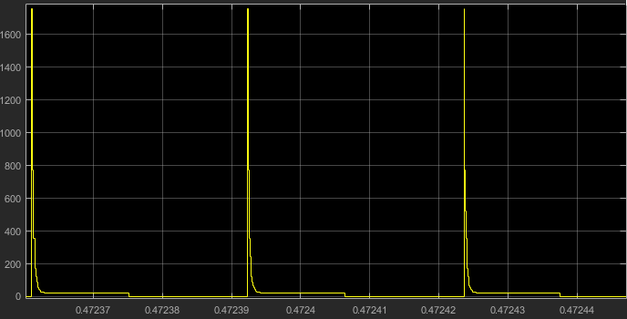

Figure: the switch stress when there is no snubber circuit

Lets design a snubber circuit.

R = 2\*pi\*f\*Lm = 12 ohm

C = 1/(2\*pi\*f\*R) = 0.414 uF

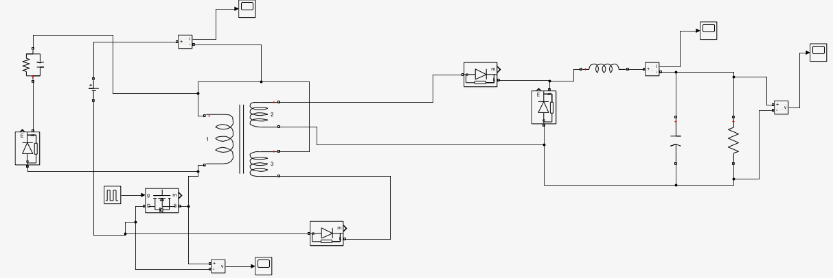

Figure: The new circuit with an added snubber circuit

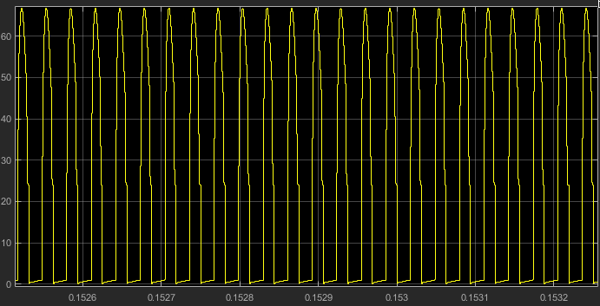

Figure: when we use the snubber given in the circuit, this is the new stress on the switch, wich is much more manageable

f)

at full load:

transformer current is 3.69 amperes and transformer copper resistance is 0.0259 ohm.

Transformer copper loss primary side = 3.69^2\*0.0259 = 0.35 W

Transformer copper loss secondary side = 2.6^2\*0.0259 =0.175 W

Reset windig copper loss = 1.95^2\*0.0259 = 0.1 W

For switching loss, lets pick a power mosfet, IRF540NSPbF

Trise = Tfall = 35\*10^-9

Vds= 75 V

Coss= 250 \* 10 ^-12 F

Crss = 40 \*10^-12 F

$switching loss=\left(Coss+Crss\right)*Vds^{2}*f=290*{10}^{-12}*{60}^{2}*32000=0.033 W$

Conduction loss = 3.69 ^2 \* 44 \*10^-3 = 0.6 W

Transformer core loss = 4.66 W

* Efficiency = Pout/Pin = 40/(40 + 0.35 +0.6 + 0.033 + 4.66 + 0.175 + 0.1 ) => n = 0.88

As the load reduces, the losses also get lower.